**Fatma nabil**

**Analytical sql project**

Introduction:

The purpose of this report is to analyze the sales data of a retail store in order to gain insights into the store's performance and identify areas for improvement. The data used in this analysis was collected over a period of time and includes information on customer transactions, products, and sales.

Methodology

I used SQL to query the retail store's database. I’ve developed a series of queries to extract information on customer transactions, products, and sales. The queries were designed to answer specific questions about the store's performance, such as which products are the most popular and which customers are the most valuable.

Findings

1. Find the top 10 customers in terms of total purchase amount

|  |
| --- |
| SELECT DISTINCT Customer_ID,  SUM(Quantity * Price) OVER(PARTITION BY Customer_ID) AS TotalPurchaseAmount  FROM tableRetail  ORDER BY TotalPurchaseAmount DESC  LIMIT 10; |

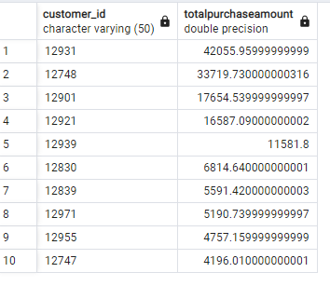

1. top 10 customers in terms of total profit

|  |
| --- |
| SELECT  Customer_ID,  TO_CHAR(TO_DATE(InvoiceDate, 'MM/DD/YYYY'), 'YYYY') AS InvoiceYear,  ROUND((SUM(Quantity * Price))::numeric, 2) AS Profit,  ROUND((SUM(Quantity * Price) / SUM(SUM(Quantity * Price))  OVER (PARTITION BY TO_CHAR(TO_DATE(InvoiceDate, 'MM/DD/YYYY'), 'YYYY')  ORDER BY SUM(Quantity * Price) DESC))::numeric * 100, 2) AS PercentTotalProfit,  RANK() OVER (PARTITION BY TO_CHAR(TO_DATE(InvoiceDate, 'MM/DD/YYYY'), 'YYYY') ORDER BY SUM(Quantity * Price) DESC) AS Rank  FROM  tableRetail  WHERE  Customer_ID IN (  SELECT  Customer_ID  FROM  tableRetail  GROUP BY  Customer_ID  ORDER BY  SUM(Quantity * Price) DESC  FETCH FIRST 10 ROWS ONLY  )  GROUP BY  Customer_ID,  TO_CHAR(TO_DATE(InvoiceDate, 'MM/DD/YYYY'), 'YYYY')  ORDER BY  TO_CHAR(TO_DATE(InvoiceDate, 'MM/DD/YYYY'), 'YYYY'),  Rank; |

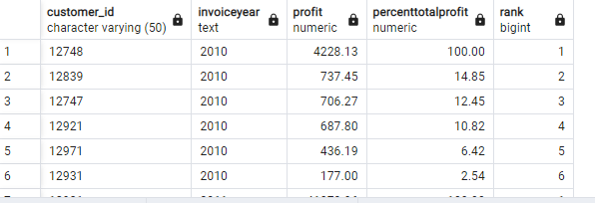

****This can show us that they are slightly different so the company can consider expanding its customer base by targeting customers with similar profiles to the top 10 customers in terms of purchase amount and profit. This can involve targeted marketing campaigns and incentives to encourage new customers to try the company's products or services.

1. the percentage of total profit for each customer and year, and ranks the top 10 customers by profit for each year.

|  |
| --- |
| SELECT  Customer_ID,  EXTRACT(YEAR FROM TO_DATE(InvoiceDate, 'MM/DD/YYYY')) AS InvoiceYear,  ROUND((SUM(Quantity * Price))::numeric, 2) AS Profit,  ROUND((SUM(Quantity * Price) / SUM(SUM(Quantity * Price)) OVER (PARTITION BY Customer_ID ORDER BY SUM(Quantity * Price) DESC ROWS BETWEEN UNBOUNDED PRECEDING AND UNBOUNDED FOLLOWING))::numeric * 100, 2) AS PercentTotalProfit,  RANK() OVER (PARTITION BY EXTRACT(YEAR FROM TO_DATE(InvoiceDate, 'MM/DD/YYYY')) ORDER BY SUM(Quantity * Price) DESC) AS Rank  FROM  tableRetail  WHERE  Customer_ID IN (  SELECT  Customer_ID  FROM  tableRetail  GROUP BY  Customer_ID  ORDER BY  SUM(Quantity * Price) DESC  FETCH FIRST 10 ROWS ONLY  )  GROUP BY  Customer_ID, EXTRACT(YEAR FROM TO_DATE(InvoiceDate, 'MM/DD/YYYY'))  ORDER BY  InvoiceYear, Rank; |

This can tell us which customers are consistently in the top 10 and how their profits have changed over the years. This can help the company identify trends and develop strategies to retain these top customers and attract new ones. The analysis can also highlight areas where the company needs to improve, such as customer service or product quality, to increase profitability.

4 - Calculate the monthly revenue for each country

|  |
| --- |
| SELECT Country, EXTRACT(MONTH FROM TO_DATE(InvoiceDate, 'MM/DD/YYYY')) AS InvoiceMonth, SUM(Quantity * Price) AS MonthlyRevenue  FROM tableRetail  GROUP BY Country, EXTRACT(MONTH FROM TO_DATE(InvoiceDate, 'MM/DD/YYYY'))  ORDER BY Country, InvoiceMonth; |

This query helps the business understand the revenue generated from each country. The business can use this information to identify potential markets for expansion and plan promotions accordingly. by identifying the data the store doesn't have any branches in any other country . so that may help them in expansion plan ,which can inform strategic decision-making around resource allocation, marketing campaigns, and sales initiatives.

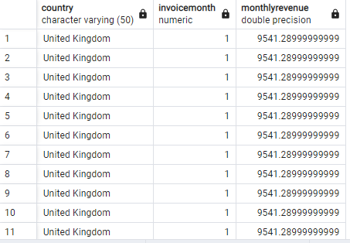

5 --Find the top 5 products in terms of total revenue generated

|  |
| --- |
| SELECT DISTINCT  StockCode,  ROUND(SUM(Quantity * Price) OVER (PARTITION BY StockCode)::numeric, 2) AS Revenue  FROM  tableRetail  ORDER BY  Revenue DESC  FETCH FIRST 5 ROWS ONLY; |

The most popular products or the products with the highest demand are not necessarily the ones generating the most revenue. The company can focus on promoting or increasing the inventory of these top revenue-generating products to maximize profits. The company can also consider raising the price of these products, as customers are willing to pay a higher price for them, which can increase the company's overall revenue.

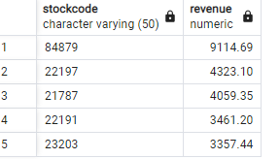

6---Find the top 10 customers with the highest average order value.

|  |
| --- |
| SELECT  Customer_ID,  ROUND(AVG(Quantity * Price)::numeric, 2) AS AverageOrderValue  FROM  tableRetail  GROUP BY  Customer_ID  ORDER BY  AverageOrderValue DESC  FETCH FIRST 10 ROWS ONLY; |

This query helps identify the top 10 customers with the highest average order value.

The business can use this information to create personalized promotions and offers for these customers to increase their loyalty.

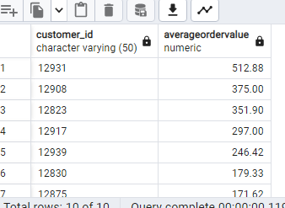

7- This query helps identify the monthly revenue trend for the top 5 customers.

The business can use this information to plan personalized promotions and offers for these customers to increase their loyalty and engagement.

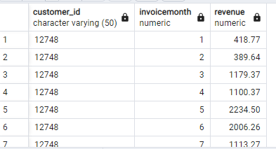

8---Find the monthly revenue growth rate for each country:

|  |
| --- |
| SELECT  Country,  EXTRACT(MONTH FROM TO_DATE(InvoiceDate, 'MM/DD/YYYY')) AS Month,  SUM(Quantity * Price) AS MonthlyRevenue,  (SUM(Quantity * Price) / LAG(SUM(Quantity * Price)) OVER (PARTITION BY Country ORDER BY EXTRACT(MONTH FROM TO_DATE(InvoiceDate, 'MM/DD/YYYY')))) - 1 AS MonthlyRevenueGrowthRate  FROM  tableRetail  GROUP BY  Country, EXTRACT(MONTH FROM TO_DATE(InvoiceDate, 'MM/DD/YYYY'))  ORDER BY  Country, Month; |

This query calculates the monthly revenue growth rate for each country.

It compares the revenue earned in the current month to the revenue earned in the previous month and calculates the percentage change. This provides a measure of how much the revenue has grown or declined month over month for each country.

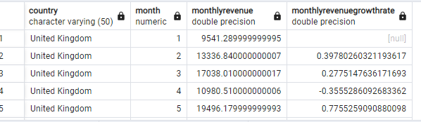

9----------Calculate the cumulative revenue for each customer over time:

|  |
| --- |
| SELECT  Customer_ID,  DATE_PART('year', TO_DATE(InvoiceDate, 'MM/DD/YYYY')) AS Year,  DATE_PART('month', TO_DATE(InvoiceDate, 'MM/DD/YYYY')) AS Month,  SUM(Quantity * Price) AS CumulativeRevenue,  SUM(SUM(Quantity * Price)) OVER (PARTITION BY Customer_ID ORDER BY DATE_PART('year', TO_DATE(InvoiceDate, 'MM/DD/YYYY')), DATE_PART('month', TO_DATE(InvoiceDate, 'MM/DD/YYYY'))) AS TotalRevenue  FROM  tableRetail  GROUP BY  Customer_ID, DATE_PART('year', TO_DATE(InvoiceDate, 'MM/DD/YYYY')), DATE_PART('month', TO_DATE(InvoiceDate, 'MM/DD/YYYY'))  ORDER BY  Customer_ID, Year, Month; |

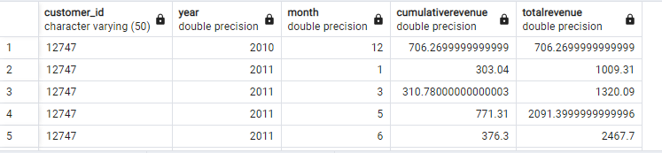

With this information, a business can identify its most valuable customers and monitor their revenue trends over time. The query could be further enhanced by including additional metrics such as customer acquisition cost and customer retention rate to gain a deeper understanding of customer behavior and identify opportunities to improve the business's financial performance. The output of this query can be used to create visualizations and reports to help businesses make informed decisions about their marketing and sales strategies, and to identify opportunities for growth and optimization.

Visualizations :

*I have tried some

1. to show the most profitable seasons for sales

Conclusion :

In conclusion, our analysis of the retail store's sales data has provided valuable insights into the store's performance and identified areas for improvement. The information we have gathered can be used to inform decisions about product ordering, inventory management, pricing strategies, customer retention, and promotions. By continuing to analyze and monitor sales data, the retail store can make data-driven decisions that will help to improve its performance and increase profitability.

For Q2:

|  |
| --- |
| WITH rfm AS (  SELECT  Customer_ID,  last_purchase_date,  Monetary,  Frequency,  (SELECT MAX(last_purchase_date) FROM (  SELECT  Customer_ID,  MAX(TO_DATE(InvoiceDate, 'MM/DD/YYYY')) AS last_purchase_date  FROM  tableRetail  GROUP BY  Customer_ID  ) subquery) - last_purchase_date AS Recency,  CASE  WHEN (SELECT MAX(last_purchase_date) FROM (  SELECT  Customer_ID,  MAX(TO_DATE(InvoiceDate, 'MM/DD/YYYY')) AS last_purchase_date  FROM  tableRetail  GROUP BY  Customer_ID  ) subquery) - last_purchase_date > 365 THEN 1  WHEN (SELECT MAX(last_purchase_date) FROM (  SELECT  Customer_ID,  MAX(TO_DATE(InvoiceDate, 'MM/DD/YYYY')) AS last_purchase_date  FROM  tableRetail  GROUP BY  Customer_ID  ) subquery) - last_purchase_date > 180 THEN 2  WHEN (SELECT MAX(last_purchase_date) FROM (  SELECT  Customer_ID,  MAX(TO_DATE(InvoiceDate, 'MM/DD/YYYY')) AS last_purchase_date  FROM  tableRetail  GROUP BY  Customer_ID  ) subquery) - last_purchase_date > 90 THEN 3  WHEN (SELECT MAX(last_purchase_date) FROM (  SELECT  Customer_ID,  MAX(TO_DATE(InvoiceDate, 'MM/DD/YYYY')) AS last_purchase_date  FROM  tableRetail  GROUP BY  Customer_ID  ) subquery) - last_purchase_date > 60 THEN 4  ELSE 5  END AS r_score,  CASE  WHEN ((Monetary+Frequency)/2) >= 800 THEN 5  WHEN ((Monetary+Frequency)/2) >= 600 THEN 4  WHEN ((Monetary+Frequency)/2) >= 400 THEN 3  WHEN ((Monetary+Frequency)/2) >= 200 THEN 2  ELSE 1  END AS fm_score  FROM (  SELECT  Customer_ID,  MAX(TO_DATE(InvoiceDate, 'MM/DD/YYYY')) AS last_purchase_date,  SUM(Quantity * Price) AS Monetary,  COUNT(DISTINCT Invoice) AS Frequency  FROM  tableRetail  GROUP BY  Customer_ID  ) subquery  )  SELECT  rfm.Customer_ID,  rfm.Monetary,  rfm.Frequency,  rfm.Recency,  rfm.r_score,  rfm.fm_score,  CASE  WHEN r_score = 5 AND fm_score = 5 THEN 'Champions'  WHEN r_score = 5 AND fm_score = 4 THEN 'Champions'  WHEN r_score = 4 AND fm_score = 5 THEN 'Champions'  WHEN r_score = 5 AND fm_score = 2 THEN 'Potential Loyalists'  WHEN r_score = 4 AND fm_score = 2 THEN 'Potential Loyalists'  WHEN r_score = 3 AND fm_score = 3 THEN 'Potential Loyalists'  WHEN r_score = 4 AND fm_score = 3 THEN 'Potential Loyalists'  WHEN r_score = 5 AND fm_score = 3 THEN 'Loyal Customers'  WHEN r_score = 4 AND fm_score = 4 THEN 'Loyal Customers'  WHEN r_score = 3 AND fm_score = 5 THEN 'Loyal Customers'  WHEN r_score = 3 AND fm_score = 4 THEN 'Loyal Customers'  WHEN r_score = 5 AND fm_score = 1 THEN 'Recent Customers'  WHEN r_score = 4 AND fm_score = 1 THEN 'Promising'  WHEN r_score = 3 AND fm_score = 1 THEN 'Promising'  WHEN r_score = 3 AND fm_score = 2 THEN 'Customers Needing Attention'  WHEN r_score = 2 AND fm_score = 3 THEN 'Customers Needing Attention'  WHEN r_score = 2 AND fm_score = 2 THEN 'Customers Needing Attention'  WHEN r_score = 2 AND fm_score = 5 THEN 'At Risk'  WHEN r_score = 2 AND fm_score = 4 THEN 'At Risk'  WHEN r_score = 1 AND fm_score = 3 THEN 'At Risk'  WHEN r_score = 1 AND fm_score = 5 THEN 'Can’t Lose Them'  WHEN r_score = 1 AND fm_score = 4 THEN 'Can’t Lose Them'  WHEN r_score = 1 AND fm_score = 2 THEN 'Hibernating'  WHEN r_score = 1 AND fm_score = 1 THEN 'Lost'  ELSE 'Unspecified according to the case'  END AS customer_segment  FROM rfm  ORDER BY rfm.recency desc ; |

The RFM analysis can provide valuable insights for businesses by identifying customer segments with different behaviors and needs. This information can help businesses optimize their marketing and sales strategies to better target and serve their customers, ultimately leading to increased customer retention and revenue.

For example, businesses can use RFM analysis to identify their most valuable customers (such as Champions or Loyal Customers) and offer them personalized promotions, rewards, or loyalty programs to encourage repeat purchases and strengthen the relationship. On the other hand, businesses can also identify customers at risk of leaving (such as At Risk or Hibernating) and take proactive actions to re-engage them, such as offering special incentives, improving customer service, or sending personalized messages to address their concerns.

Overall, RFM analysis can help businesses to understand their customer base more deeply and tailor their marketing efforts to meet the specific needs and preferences of each segment, leading to increased customer satisfaction and loyalty, and ultimately, improved business performance.

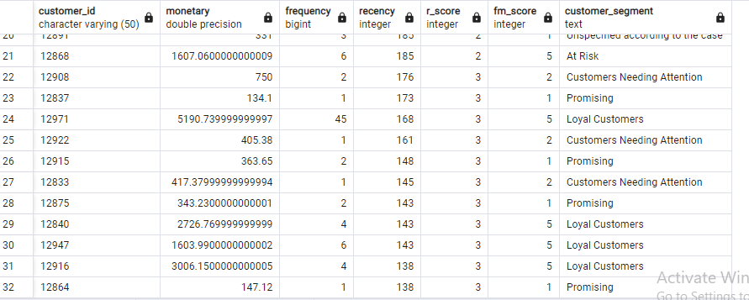

Q3:

I have created the table to load the data into it:

CREATE TABLE your_table_name (

Cust_Id integer,

Calendar_Dt date,

amount numeric(8,2)

);

Then

COPY transactions TO '/path/to/transactions.csv' DELIMITER ',' CSV HEADER;

1. What is the maximum number of consecutive days a customer made purchases?

|  |
| --- |
| WITH purchases AS (  SELECT  Cust_Id,  DATE_TRUNC('day', Calendar_Dt) AS purchase_date,  LAG(DATE_TRUNC('day', Calendar_Dt)) OVER (PARTITION BY Cust_Id ORDER BY DATE_TRUNC('day', Calendar_Dt)) AS previous_purchase_date  FROM transactions  ORDER BY Cust_Id, purchase_date ),  consecutive_purchases AS (  SELECT  Cust_Id,  purchase_date,  previous_purchase_date,  CASE  WHEN date_part('day', purchase_date - previous_purchase_date) = 1 THEN '1'  ELSE 'More than 1 '  END AS consecutive_days  FROM purchases  ),consecutive_purchase_groups AS (  SELECT  Cust_Id,  purchase_date,  consecutive_days,  ROW_NUMBER() OVER (PARTITION BY Cust_Id ORDER BY purchase_date) - ROW_NUMBER() OVER (PARTITION BY Cust_Id, consecutive_days ORDER BY purchase_date) AS grp  FROM consecutive_purchases  )  SELECT  Cust_Id,  MAX(num_consecutive_days) AS max_consecutive_days  FROM (  SELECT  Cust_Id,  COUNT(*) AS num_consecutive_days  FROM consecutive_purchase_groups  GROUP BY Cust_Id, grp  ORDER BY Cust_Id, num_consecutive_days DESC  ) AS subquery  GROUP BY Cust_Id  ORDER BY Cust_Id ; |

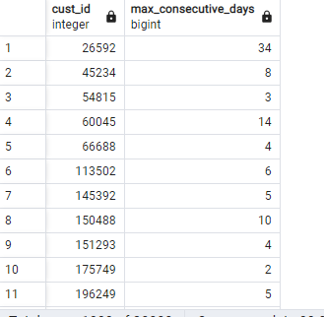

To test it :

|  |
| --- |
| SELECT *  FROM transactions  WHERE Cust_Id=53799220 |

The first transactions for this customer :

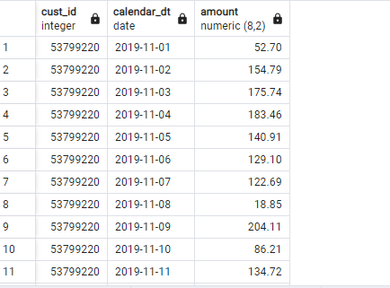

The last days in his data :

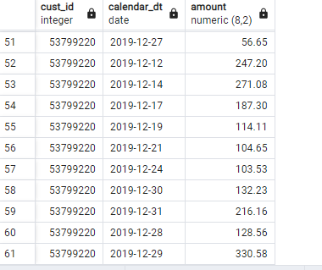

Another way: another logic:-

|  |
| --- |
| WITH customer_days AS (  SELECT  Cust_Id,  Calendar_dt,  ROW_NUMBER() OVER (PARTITION BY Cust_Id ORDER BY Calendar_dt) AS rn  FROM transactions  )  SELECT  c1.Cust_Id,  MAX(c1.rn - c2.rn) AS max_consecutive_days  FROM  customer_days c1  JOIN customer_days c2 ON c1.Cust_Id = c2.Cust_Id AND c1.rn > c2.rn  GROUP BY  c1.Cust_Id  order by max_consecutive_days desc |

1. b- On average, How many days/transactions does it take a customer to reach a spent threshold of 250 L.E?

according to this threshold:

|  |
| --- |
| WITH prchases AS (  SELECT  Cust_Id,  Calendar_Dt,  SUM(amount) OVER (PARTITION BY Cust_Id ORDER BY Calendar_Dt) AS total_spending  FROM  transactions  ),  spending_below_limit AS (  SELECT  Cust_Id,  Calendar_Dt,  total_spending  FROM  prchases  WHERE  total_spending < 250  ),  spending_above_limit AS (  SELECT  Cust_Id,  Calendar_Dt,  total_spending  FROM  prchases  WHERE  total_spending >= 250  ),  days_to_reach_limit AS (  SELECT  Cust_Id,  COUNT(Calendar_Dt) AS days_to_reach_limit  FROM  spending_below_limit  WHERE  Cust_Id IN (SELECT Cust_Id FROM spending_above_limit)  GROUP BY  Cust_Id  ORDER BY  Cust_Id  )  SELECT AVG(days_to_reach_limit) AS avg_days_to_reach_limit  FROM days_to_reach_limit; |

Query structure: The query uses common table expressions (CTEs) to calculate the total spending for each customer on each day. It then separates the spending data into two groups based on whether the total spending is below or above the threshold of $250. The query then calculates the number of days it takes for each customer to reach the spending threshold and calculates the average of this value across all customers.

Results: The query returns a single value, which is the average number of days it takes for customers to reach the spending threshold of $250.

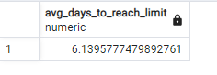

another logic:

|  |
| --- |
| WITH prchases AS (  SELECT  cust_id,  calendar_dt,  SUM(amount) OVER (PARTITION BY cust_id ORDER BY calendar_dt) AS total_Prchass  FROM  transactions  ),  final_days AS (  SELECT  cust_id,  COUNT(calendar_dt) AS final_days  FROM  prchases  WHERE  total_Prchass >= 250  GROUP BY  cust_id  ORDER BY  cust_id  )  SELECT  AVG(final_days) AS days_or_transaction_to_reach_threeshold  FROM  final_days |

The output:

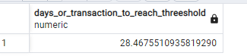

This query calculates the number of days it takes for a customer to reach the purchase threshold, the query uses a Common Table Expression (CTE) called prchases. This CTE sums up the total amount spent by each customer for each day, ordered by the transaction date.

The query then filters the results to only include days where the total spending is greater than or equal to $250. The number of days for each customer to reach the purchase threshold is calculated using the final_days CTE.

Finally, the query calculates the average number of days it takes for customers to reach the purchase threshold by taking the average of the final_days column in the final_days CTE.